
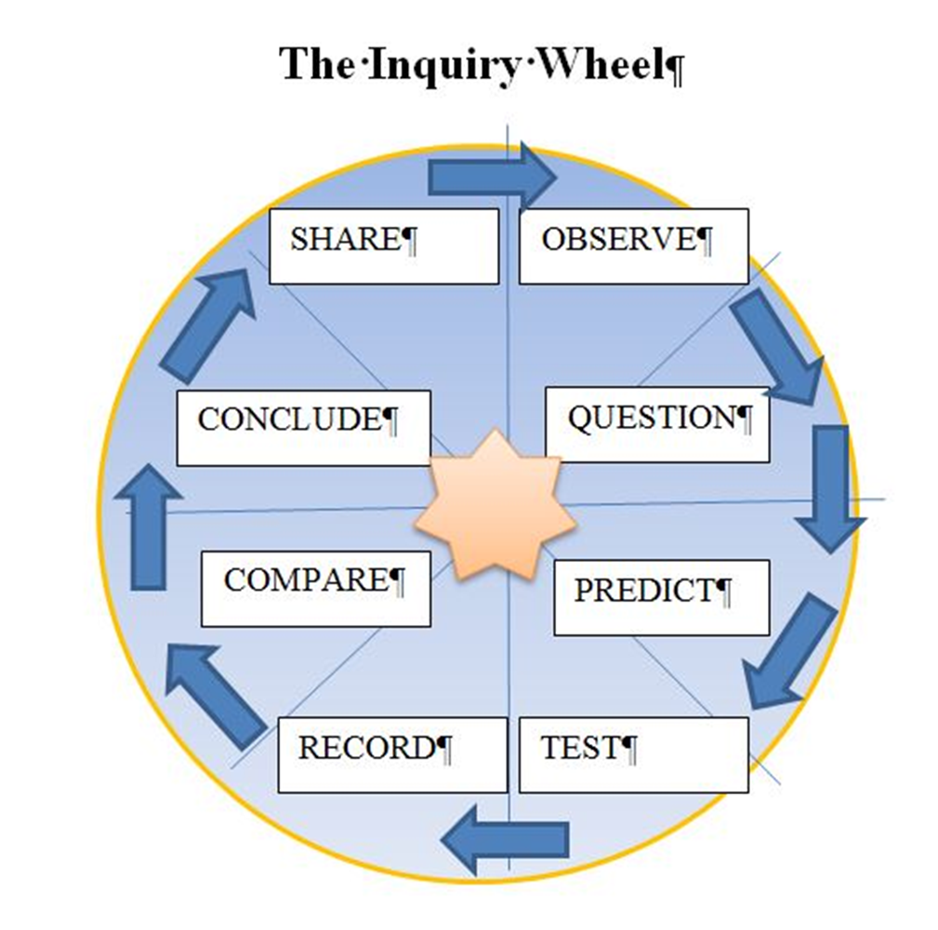
?Can digital technology be used?
Based on the observation, ask open-ended questions.
Using comparisons, charts, and graphs to see what you found out. Compare it to your prediction.
? Where can hands-on math be incorporated?
? Does something need to be engineered?
Design an experiment.
Sketch and plan, gather materials.
? Which arts form will work the best?
Write down results in journal. Make sketches. Record measurements.
Summarize what you learned
Tell others about what you did and learned through the arts –draw it, sing it, act it, dance it.
Present the WOW.
Observe using senses, measuring tools, drawing, and recording tools
Pick a question and make a prediction.
Begin again: Ask a new question about the same WOW or present a new one based on these results.

