Name ___________________________________________ Date _________________________________

Observation Lab: Measurement

- Take your object to each center
- Observe it closely using the scientific measuring tools.
- Fill in the data below.

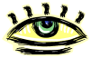  What it looks like… | 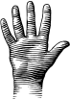  What it feels like… | 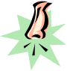  How it smells/sounds… | 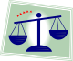  Mass in grams
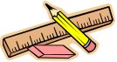  Length in cm | Width in cm. | Depth in cm. | 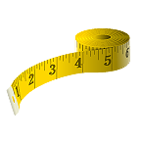  Circumference in cm.
Add any other property that will help identify this sample of matter:

